**Dockerized Playwright Test Environment**

**Overview**

This document explains how to set up a Dockerized environment for running Playwright tests with Java. It includes the creation of the Dockerfile and entrypoint.sh file, and provides detailed instructions for building and running the Docker image.

**Dockerfile**

The Dockerfile is used to build the Docker image with all necessary dependencies and configurations.

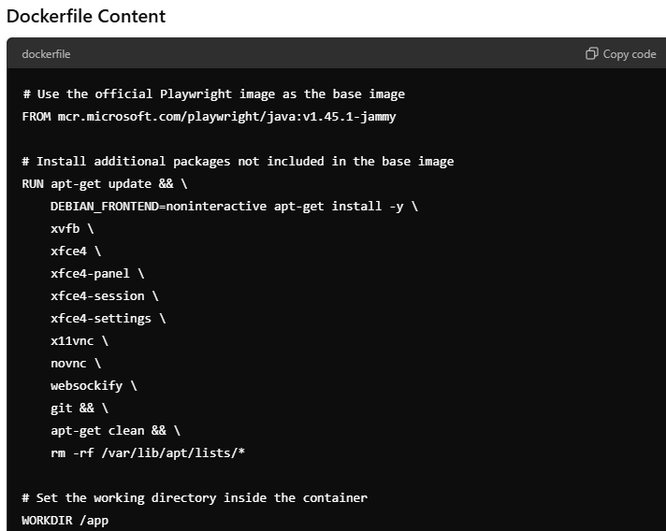

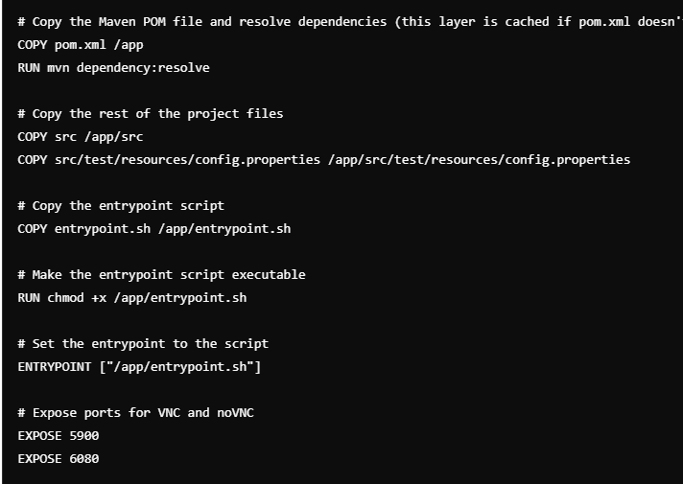

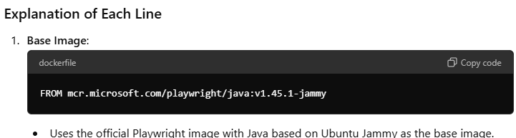

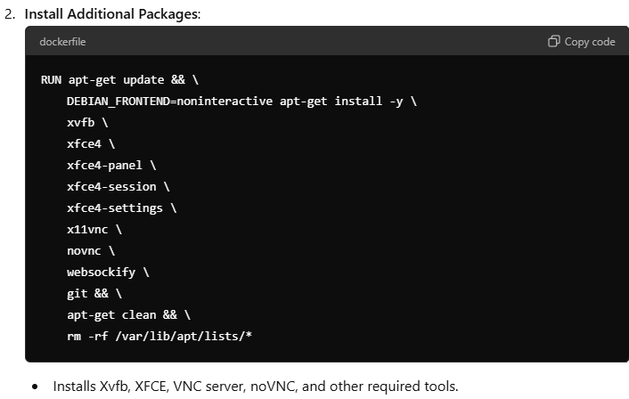

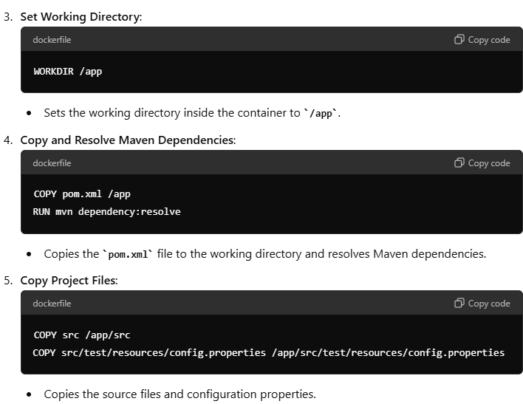

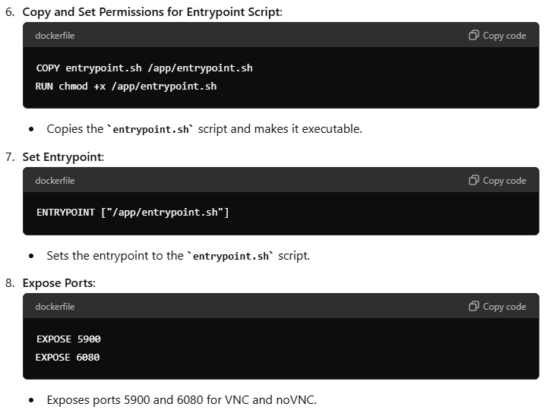

**Entrypoint Script**

The entrypoint script sets up the environment and starts the necessary services.

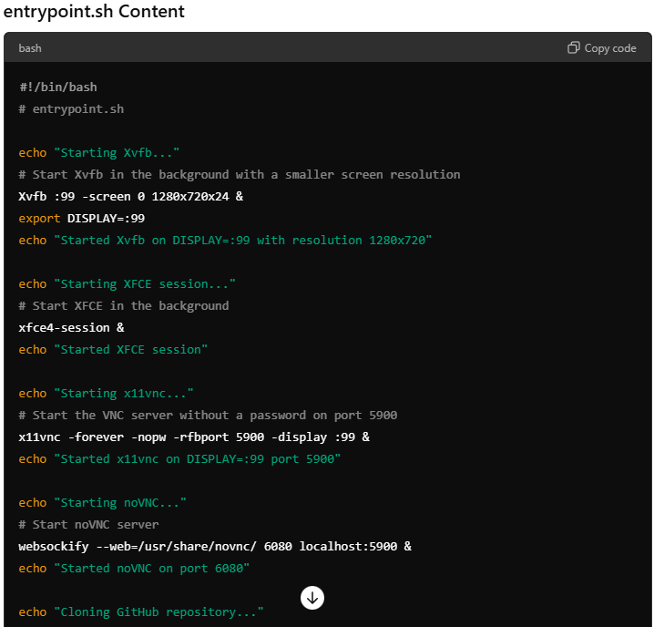

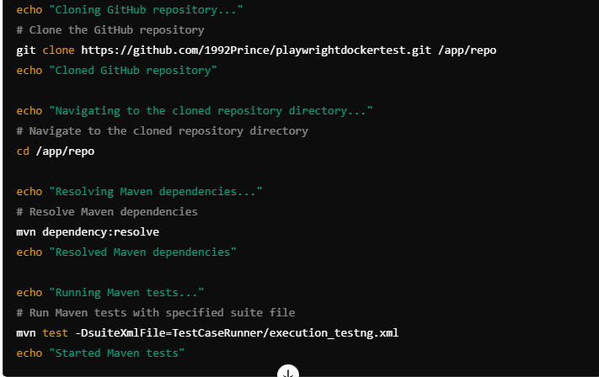

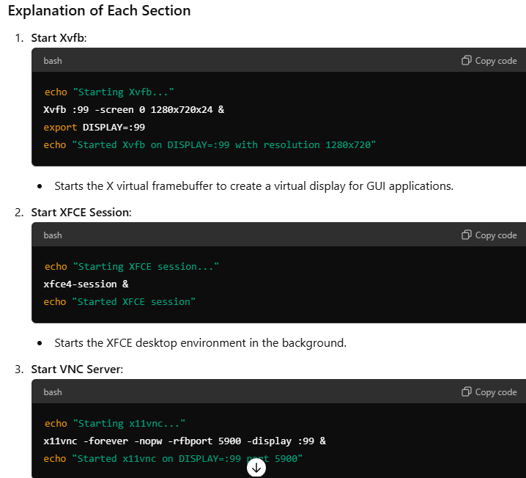

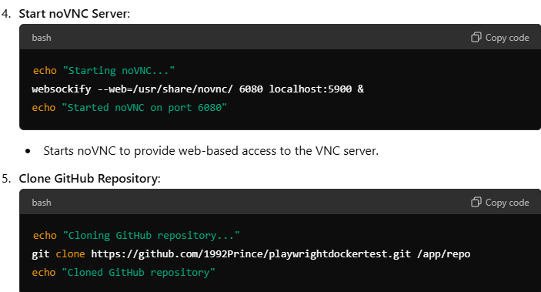

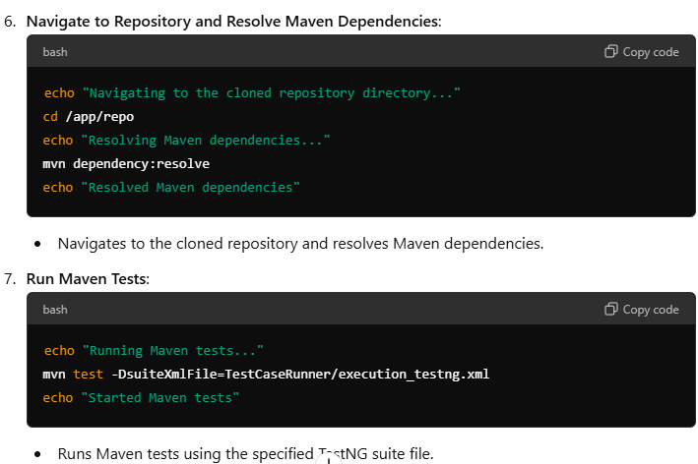

**Creating a Docker Volume for Maven Repository**

Creating a Docker volume allows you to persist Maven dependencies across container runs.

**Command to Create Docker Volume**

|  |
| --- |
| docker volume create maven-repo |

**Purpose**

* **Persistence**: Ensures Maven dependencies are not lost when the container is removed.
* **Efficiency**: Reduces time and bandwidth by reusing downloaded dependencies.

**Building and Running the Docker Image**

**Building the Docker Image**

|  |
| --- |
| docker build -t playwright-java-image . |

Running the Docker Container with Volume

|  |
| --- |
| docker run -p 5900:5900 -p 6080:6080 -v maven-repo:/root/.m2 --name playwright-container playwright-java-image |

**Running the Docker Container Without Specifying a Container Name**

If you want Docker to automatically assign a name to the container:

|  |
| --- |
| docker run -p 5900:5900 -p 6080:6080 -v maven-repo:/root/.m2 playwright-java-image |

**Accessing noVNC**

To access the running tests via noVNC in your browser, open the following URL:

|  |
| --- |
| http://localhost:6080 |

<http://localhost:6080/vnc.html>

Note – If we are making any changes in Dockerfile or entry file then again we need to build docker image.

Thank you!